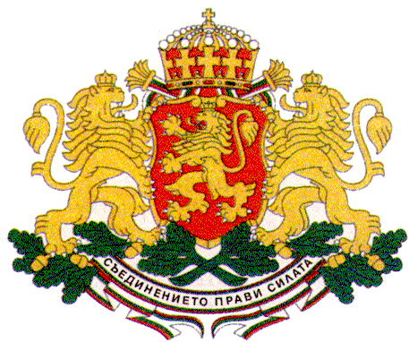 | PERMANENT MISSION OF THE REPUBLIC OF  BULGARIA  TO THE UNITED NATIONS

11 East 84th Street, New York, NY 10028, Tel: (212) 737 4790, Fax: (212) 472 9865, e-mail: bulgaria@un.int

Annual Session of the UNFPA/UNDP/UNOPS Executive Board
Special briefing on Population Dynamics and Sustainable Development in Europe and Central Asia

New York, 5 June 2018, 1.15 pm – 2.30 pm, CR 3, UNHQs
Investing in Human Capital Emphasizing Youth
H.E. Mr. Georgi Panayotov, Ambassador, Permanent Representative of Bulgaria to the UN

Ambassador Besiana Kadare,
Executive Director Natalia Kanem,
Excellencies,
Distinguished delegates,
Dear guests,
I would like to commend the Permanent Mission of Albania and UNFPA for organizing this special briefing on population dynamics and sustainable development which is very timely considering the current global trends in youth development, the demographic challenges our region faces and the importance of harnessing youth potential for achieving sustainable development and inclusive societies for all.
For the first time in the history of humanity young people form a quarter of the world’s population thus representing a major human resource for the development and prosperity of their societies and the global community in general.
However, countries in Eastern Europe have been experiencing significant demographic transformations in the last 30 years and Bulgaria is no exception. Population decline, migration, and population ageing have a tremendous impact on the economies and societies of many countries in the region.

In 2016 Bulgaria had a crude birth rate of 9.1 per mille and the total fertility rate remains low with 1.54 children per woman - which is up significantly from the late 1990s, but still below replacement and require some management measures to counteract. The Government Programme for the period 2017 - 2021 is the first one that aims at overturning the trend through active measures to increase the birth rate, reduce youth emigration, and build up regulatory and institutional capacity to implement a modern immigration policy tailored to the needs of the Bulgarian business.
Bulgaria has a high Human Development Index of 0.794, ranking 56th in the world in 2016, and holds the 38th position in Newsweek’s rankings of the world’s best countries to live in, measuring health, education, political environment and economic dynamism. Bulgaria’s HIV rate is also among the lowest in the world.
The Government of Bulgaria has identified as one of its major priorities on the political agenda of the current Bulgarian Presidency of the Council of the European Union the Future of Europe and Young People with 3 specific areas for further action, namely youth, peace and security; demographic growth; and the role of young people for achieving equality and sustainable development. In April Bulgaria hosted a major European Youth Conference which provided a platform for valuable exchange of ideas between Governments and young people with the aim to develop the new EU Youth Strategy through a participatory and inclusive process. The Conference benefited also from the insightful input of distinguished senior officials of the UN.
Youth empowerment and youth participation in decision-making are key priorities of the Bulgarian Government. Bulgaria has a long tradition of actively involving young people in the development and implementation of policies and programmes that impact their lives and ensuring their meaningful participation in all spheres of the political and public life through broad and inclusive consultations. Bulgaria continues to strongly advocate for a more substantial involvement of young people in global affairs as well, including through the UN Youth Delegate Programme, which Bulgaria is successfully implementing in the last more than 10 years, thus ensuring that young people have a say in global processes and their voices are heard and taken into consideration.
Bulgaria is convinced that children and young people should be the key agents of positive social change globally and pays special attention to child and youth empowerment through education. Fostering the acquisition of skills is crucial for empowering youth to successfully enter the changing labour markets. However, youth unemployment remains a major concern not only in our region but worldwide. Globally, young people tend to be three times more likely than adults to be unemployed.

The Government of Bulgaria takes special measures to substantially reduce the proportion of young people not in employment or training by providing support and investment in both formal and non-formal education. Quality education is crucial for the development of key competences and skills that match labour market demands. Social entrepreneurship is another tool to address unemployment challenges in a sustainable way by empowering young people to create job opportunities themselves which in the long run contributes also to resolving major social issues, including for young persons with disabilities.
Bulgaria highly values in this regard the crucial role of civil society, especially youth and youth-led organizations and young volunteers, for amplifying the contributions of young people to economic development and social cohesion. In Bulgaria we have many positive examples of young volunteers engaged in social initiatives, including those related to refugee integration, social entrepreneurship for persons with disabilities, human rights campaigns, sustainable development projects, etc.

Thank you!

